
NSANJE DISTRICT MOCK
MALAWI SCHOOL CERTIFICATE OF EDUCATION EXAMINATION MATHEMATICS
Subject Number: M131/I
Wednesday, 3 April Time Allowed: 2 hours
2:00-4:00 pm
PAPER I
(100 marks)
Instructions
Question  Number | Tick if  answered | Do not write in these columns
1
2
3
4
5
6
7
8
9
10
11
12
13
14
15
16
17
18
19
20
Total
- This paper contains 12 printed pages. Please check.
- Answer all the 20 questions in this paper.
- The maximum number of marks for each answer
is indicated against each question.
- Write your answers in the spaces provided on the
question paper.
- Calculators may be used.
- All working must be clearly shown.
- Write your Name and School Name at the top of each page of your question paper in the spaces provided.
- In the table provided on this page, tick against the question number you have answered.

- Factorise completely $x^{2}-2xy-15y^{2}$ (3 marks)

- Simplify ${54}_{6}-{35}_{6}$, giving your answer in base 4 (5 marks)

- If $g\left(t\right)=\frac{3t}{8t-v}$, find the value of $g(-v)$ in its simplest form (3 marks)

- Find the yearly income of 9% stock bought at K102 for K12 968. (4 marks)

- 45 g of rain water of density 1.2 g/cm³ is mixed with 22 cm³ of sea water of density
1.25 g/cm³. Calculate the density of the mixture. (5 marks)

- Solve the equation $\log{5}{+\log\left(2x+10\right)-2=\log{(x-4)}}$ (5 marks)

- Solve the simultaneous equations:
$$xy=4$$
$x+y=5$. (5 marks)

- An exterior angle of a regular convex polygon is 36º. Find the sum of exterior angles of the polygon. (6 marks)

- Without using a calculator or figure tables, simplify $\frac{3\sqrt{3}-2\sqrt{5}}{2\sqrt{3}+2\sqrt{5}}$ leaving your answer with a rational denominator. (6 marks)

- Given that $m=n\sqrt{a^{2}-b^{2}}$, make b subject of the formula. (5 marks)

- Figure 1 below shows a right angled triangle RBQ. Angle BAQ= 40º angle PQR = 30º and AB= 5 cm.
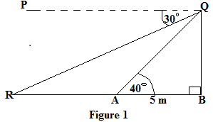
Calculate the length of AR. (4 marks)

- Given that $\left[\begin{matrix}2 & a \\ b & 4\end{matrix}\right]\left[\begin{matrix}2 & 1 \\ 3 & 4\end{matrix}\right]=\left[\begin{matrix}7 & 6 \\ 18 & 19\end{matrix}\right]$, calculate the values of a and b. (5 marks)

- The mass (M) of a cylindrical tin varies jointly with its height (h) and the square of its radius (r). If the tin 50 cm high and of radius 2 cm has a mass of 540 g; find the mass of cylindrical tin 10 cm high and radius 4 cm. (5 marks)

- A cone of base diameter 21 m is 5 m high. Assuming that the cone is filled with sugar, calculate the mass of the sugar in tonnes if 1 metre ha a mass of 2.5 tonnes.
(Take π=$\frac{22}{7}$). (5 marks)

- In Figure 2, PQR is a triangle inscribed in a circle. Tangent SPT to the circle meets tangent XRT at an angle of 40º and line QP is parallel to line XRT
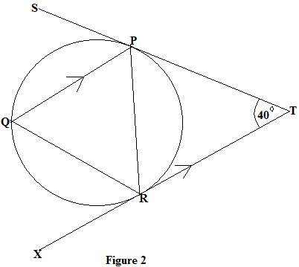
Find the value of angle SPQ. (5 marks)

- The probability that a certain student passes examinations is $\frac{4}{5}$. If she passes, the probability that she does not get a job is$\frac{3}{8}$ . If she does not pass the probability that she gets a job is$\frac{1}{4}$. Use the tree diagram to find the probability that she gets a job. (5 marks)

- Figure 3 is a diagram that shows a region A bounded by three inequalities P, Q and R.

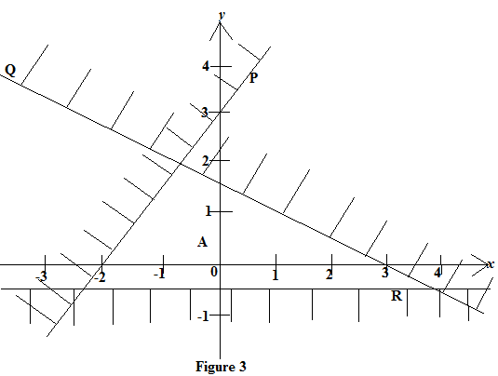

Find the inequalities that define the region A. (7 marks)

- Calculate the variance of the following set of data:
x, x+1, x+2, x+3, x+4. (5 marks)

- Using a ruler and a pair of campuses only, construct in the same diagram, a triangle LMN in which LM =6.5 cm, angle LMN = 60º and MN = 5 cm. Construct an inscribed circle of the triangle LMN. Measure and state the radius of the circle. (6 marks)

- A straight line passes through A (5, 7) and B (0, -1). Another straight line passes through
Q (-3,-5) and R(2, 3). Show that AB is parallel to QR. (5 marks)

